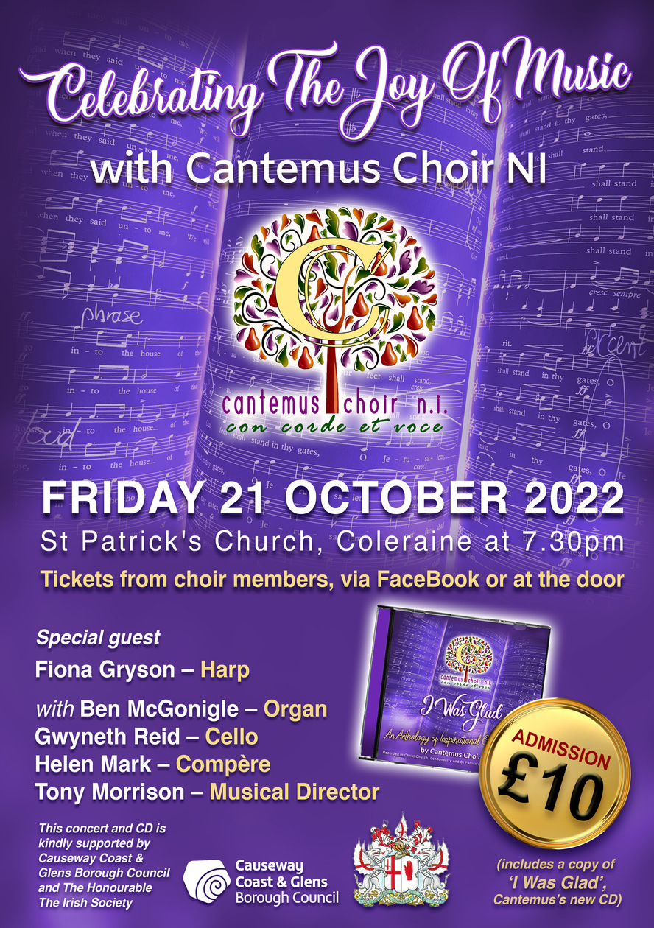

From Sunday 2nd October there will be an opportunity to donate non perishable items to be given to the Foodbank at Building Ballysally Together.

Parish office:
St. Andrew’s Church Hazeldene Drive Ballysally
opening hours Tuesday – Friday 10am – 4pm
028 7034 4213
Please contact us if you know anyone who is ill or needs a clergy visit.

St. Patrick’s and St. Andrew’s
Weekly News sheet

Sunday 9th October 2022

This Sunday 9th October Harvest Thanksgiving St. Patrick’s 10am & St. Andrew’s 11.30am.
Speaker Idan Pinhass [ Church’s ministry among Jews]

Next Sunday Morning Prayer [please note this is not Family Service due to GB/BB enrolment on 23rd] St. Patrick’s 10am & St. Andrew’s 11.30am.

GB/BB Enrolment on 23rd October in St. Patrick’s at 11.00am. No Service in St. Andrew’s
St. Andrew’s are warmly invited to join St. Patrick’s for the enrolment

Parish Prayers – Every Tuesday - St. Andrew’s Church Ballysally at 7pm please join us, everyone welcome.
Wednesday Communion continues at 1.00pm.

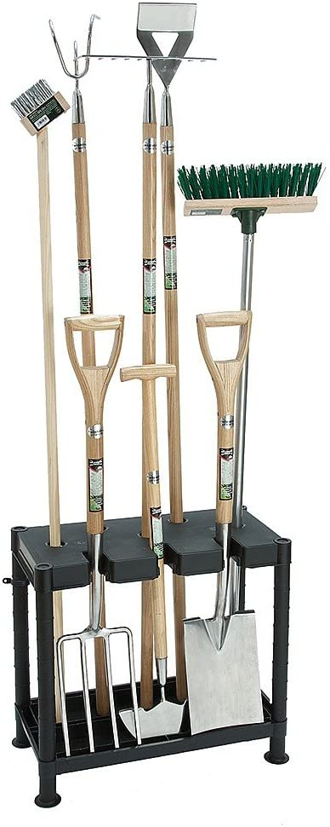
Next Groundforce Saturday 8th October 9.30am.
All help welcome!!

Next Meeting: Monday 9th October
Speaker Pamela Blair [Musical Therapist]

Oct 2022 PRAYER POINTERS
1 Peter 4 v7 ….be clear minded and self-controlled so that you can pray.
Our World Almighty God, in our harvest celebration month, we give You thanks for all christian people on the earth. We also praise You for the beautiful world, which You have created for our enjoyment. As we say in the Lord’s Prayer “ Your will be done on earth as it is in heaven” we acknowledge Your goodness towards us and seek Your will for our world.
This month we pray especially for the world leaders and governments who have great responsibility on their shoulders during the uncertain times we are living through. Lord, God, we are mindful that You can work through the leadership and governing forces of nations to bring about Your aims, even when they may be antagonistic towards You and the people who seek to live by Your guidance. The biblical story of Daniel shows us what a righteous young man, (a foreigner in a hostile land) can achieve by his faithfulness in seeking Your guidance daily through life. We give you thanks for Your words of encouragement in scripture which constantly remind us of Your unseen, yet ever present power to change very difficult situations. Please raise up “Daniel like” advisers who will speak Your truth, with a gentle spirit, which will turn away angry reaction and soften the hearts of stubborn, wilful leadership which threatens the nations of our world.
Please pray for the ongoing work of our Mission partners: The McConnells, the Creightons, The Watsons and Claire Holmes. We are told in scripture that Your word will not return empty and we ask that this is true for “seed” planted for You. (The sower Parable Mark 4:3-20)
Our Community We give thanks for the existing, underpinning Christian values which are shared in our state and independent sector schools each week. Please pray for a fresh awakening of the Holy Spirit to guide the education trainers and leaders as they plan and make changes to curriculums, which may affect what is taught to our children. We also pray for your wisdom and guidance to underpin those in government and education who have overall responsibility for the higher education and technical training provision for our young people and mature learners.
Also pray that parents and other family members will be vigilant and encourage their children in the Christian faith at home by their own examples. Please guide us in how we can best support family life with care and support for all children and young people in our church congregations.
Our church In the journey of life we each face many challenges, joy and sorrows. Please help us to see everything we meet with the grace which You promise us each day. Please help us to seek You first in all our responses.
Please pray for the prayer life in both St Patrick’s and St Andrew’s to be renewed with the guidance of the Holy Spirit as we begin again to have face to face weekly prayer meetings. (starting on Tuesday evening 4th October in St Andrew’s) We pray for willing parishioners from each congregation to commit to joining this essential ministry in our church life. We ask for growth in faith for all involved, both individually and as a community of believers.
We ask that You will keep us diligent in our daily prayers for others as well as seeking the guidance of your Holy Spirit in our private worship. Please show us how to be “salt” and “light” where we live and work . ( Matthew 5: 13-16)

GB Wednesdays from 6.30pm
Contact Alice: 07807178380

BB Thursdays from 6.15pm
Contact Elaine 07892701733

SS every Sunday except Family Service
10.00am St. Patrick’s 11.30am St. Andrew’s
Contact office 02870344213

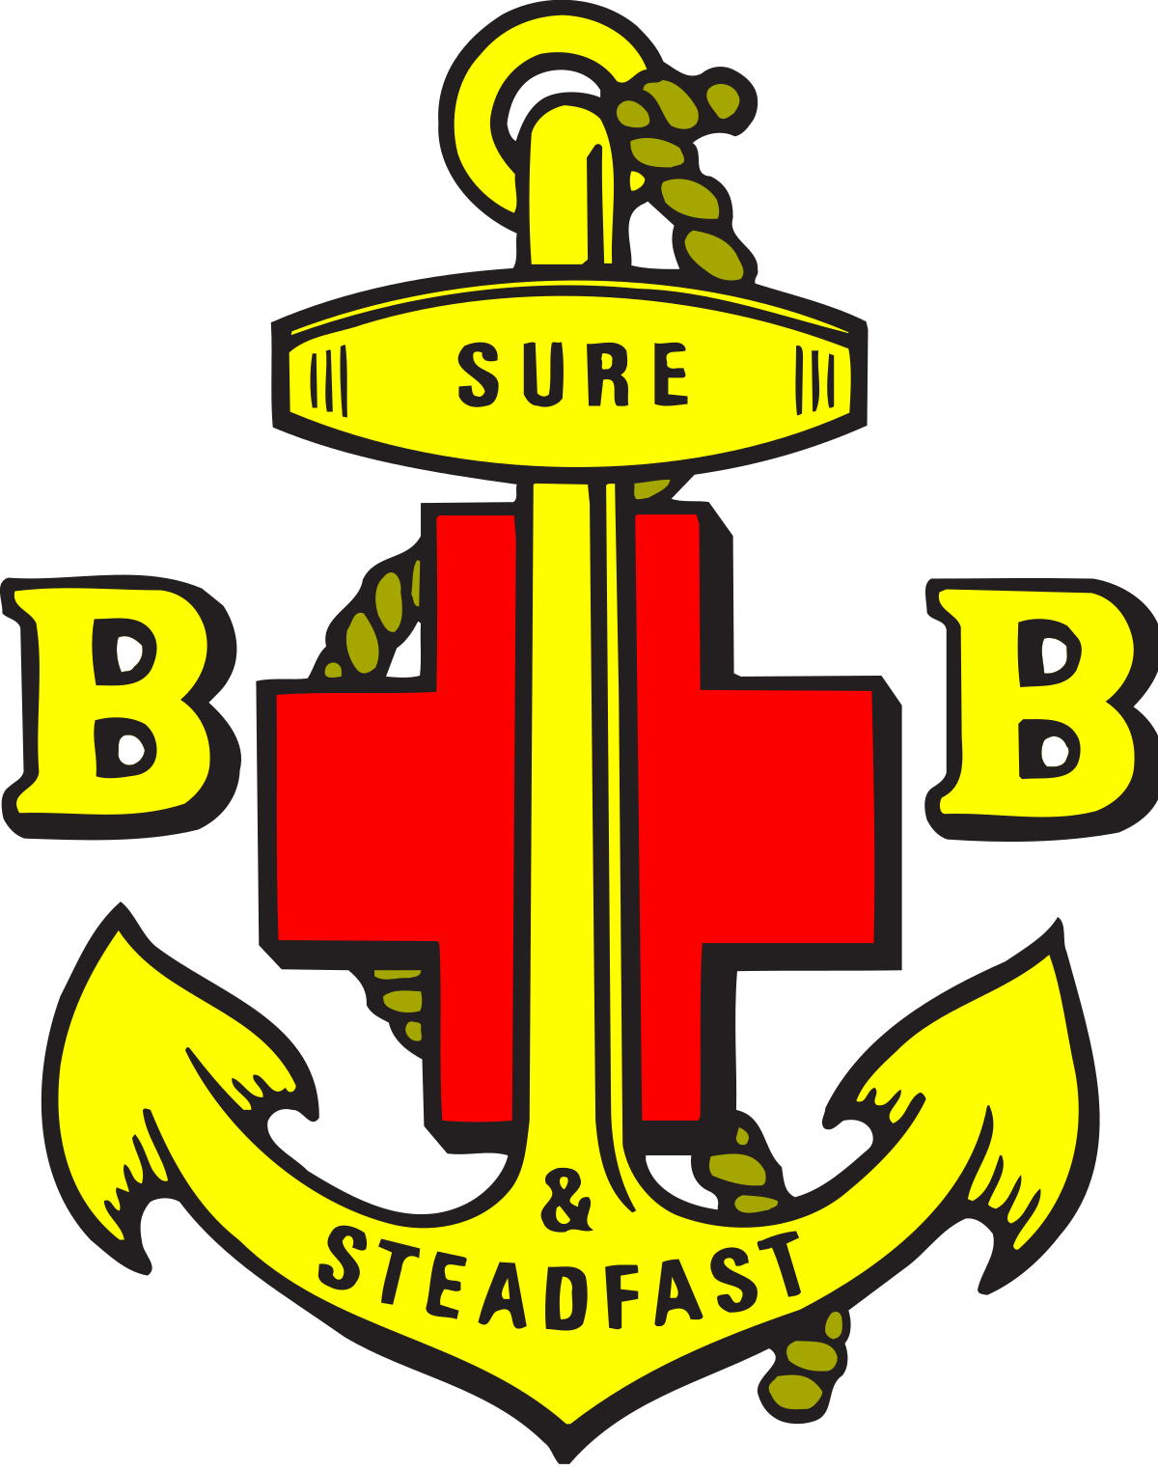
GB/BB Enrolment

When: Sunday 23rd October 2022
Where: St. Patrick’s Church
Time: 11.00am

Guest Speaker

GB will meet in St. Patrick’s Church on Wednesday 19th October at 6.30pm [front door]
